 [Translated from Chinese (Simplified) to English - www.onlinedoctranslator.com](https://www.onlinedoctranslator.com/en/?utm_source=onlinedoctranslator&utm_medium=docx&utm_campaign=attribution)

**IDH42**

**Integrated pulse open loop stepper driver**

**User Manual V1.0.2**

Shenzhen Gerui IoT Technology Co., Ltd.

**Table of contents**

one,Product Introduction 1

1.1 Product Overview 1

1.2 Product Features 1

1.3 Application Areas 1

two,Electrical, Mechanical and Environmental Specifications 2

2.1 Mechanical installation diagram 2

2.2 Installation Notes 2

2.3 Electrical specifications 3

2.4 Operating environment and parameters 3

three,Driver interface and wiring introduction 3

3.1 Interface Diagram 3

3.2 Interface Description 3

3.2.1 Control signal interface 4

3.2.2 Output signal interface 4

3.2.3 Motor control output interface 4

3.2.4 Power input interface 4

3.2.5 Status Indicator 5

3.3 Input control signal 5

3.3.1 Input control signal interface circuit 5

3.3.2 Control signal timing diagram 5

3.3.3 Control signal mode setting 6

3.4 Output control signal 6

3.4.1 Used as alarm output 6

3.5 Wiring requirements 7

Four,DIP switch function setting 7

4.1 Current Setting 8

4.2 Mode Settings 8

4.3 Subdivision and spontaneous pulse speed setting 8

4.3.1 Segmentation Settings 8

4.3.2 Spontaneous pulse speed setting 9

five,Power supply selection 9

six,Indicator lights and alarm indicators 10

seven,Warranty and after-sales 11

7.1 Warranty 11

7.1.1 Free warranty 11

7.1.2 Warranty exclusion 11

7.2 Exchange 11

7.2.1 Replacement of defective product 11

7.2.2 Exchange for non-product failure 12

7.3 Returns 12

7.4 After-sales service 12

eight,Revision History 13

# **Product Introduction**

## **1.1 Product Overview**

IDH42 integrated pulse open-loop stepper driver is a new type of integrated motor driver newly launched by Green IoT Technology Co., Ltd. It adopts the latest dedicated motor control digital signal processor to improve the overall performance of the motor, reduce the heat generation of the motor and reduce the vibration of the motor. It adopts an integrated design of motor and driver, which makes the installation more compact and reduces external interference.

## **1.2 Product Features**

●Integration of motor and drive saves wiring labor

●Small size, easy to install

●New generation 32-bit DSP technology, good stability, strong compatibility and high cost performance

●External dial to set the driver current,Working mode,Segmentation

Optically isolated differential signal input

●Built-in micro-segmentation, excellent low-speed stability

●The impulse response frequency can reach up to 200KHz (higher can be modified)

●Subdivision setting range 200-40000, Spontaneous pulse speed setting range 30-720r/min

●Precise current control greatly reduces motor heating

●Low vibration and low noise

●With overvoltage, undervoltage, phase loss and other alarm protection functions

Input voltage range:DC12V~40V

## **1.3 Application Areas**

Suitable for various small and medium-sized automation equipment and instruments, such as medical equipment, testing equipment, marking machines, plotters, etc. It meets customers' requirements for low noise, low heat generation, convenient wiring, and stronger anti-interference.

# **Electrical, Mechanical and Environmental Specifications**

## **2.1 Mechanical installation diagram**

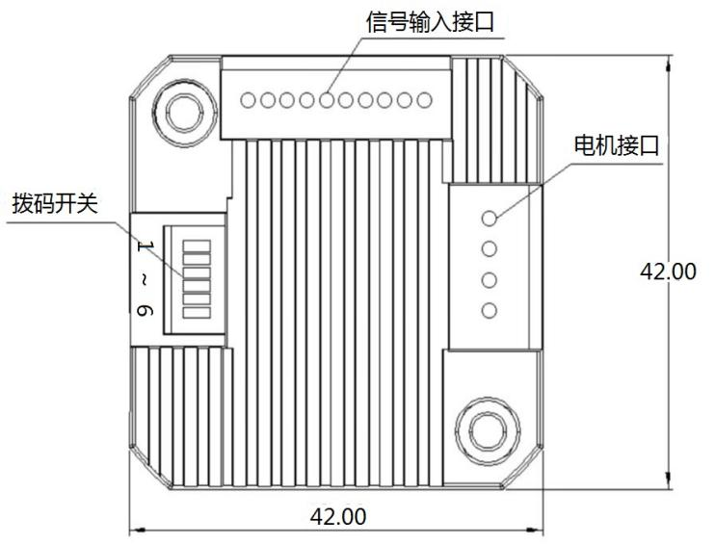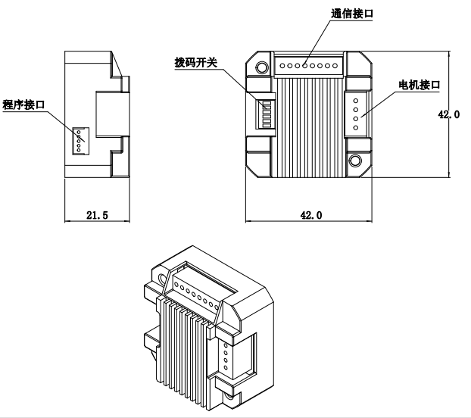

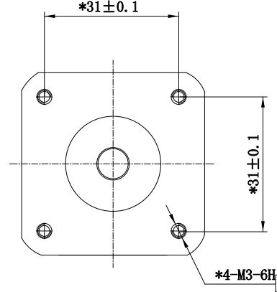

Figure 2.1 Installation dimensions (unit: mm)

## **2.2 Installation Notes**

1. When installing the integrated stepper driver, do not knock on the rear end cover of the motor to avoid affecting the operating performance. When designing the installation dimensions, the size and wiring of the wiring terminals must be considered.
2. In order to ensure good heat dissipation conditions, a larger installation interval must be reserved as much as possible during actual installation.If multiple integrated drives are installed side by side, fans can be installed to create strong air convection on the surface of the integrated drives to assist in heat dissipation and ensure that the drives operate within a reliable operating temperature range.

## **2.3 Electrical specifications**

|  |  |  |  |  |
| --- | --- | --- | --- | --- |
| **illustrate** | **IDH42** | | | |
| **Minimum** | **Typical Value** | **Maximum** | **unit** |
| **Input power voltage** | 12 | twenty four | 40 | VDC |
| **Control signal input current** | 7 | 10 | 16 | mA |
| **Step pulse frequency** | 0 | - | 200 | KHz |
| **Insulation resistance** | 50 |  |  | MΩ |

## **2.4 Operating environment and parameters**

|  |  |  |
| --- | --- | --- |
| **Cooling method** | | Natural cooling, fan cooling |
| **Usage Environment** | **occasion** | Do not place it near other heating equipment. Avoid dust, oil mist, corrosive gas, high humidity and strong vibration. Flammable gas and conductive dust are prohibited. |
| **temperature** | 0——50℃ |
| **humidity** | 40-90%RH |
| **vibration** | 10~55Hz/0.15mm |
| **Storage temperature** | | -20℃~65℃ |

# **Driver interface and wiring introduction**

## **3.1 Interface Diagram**

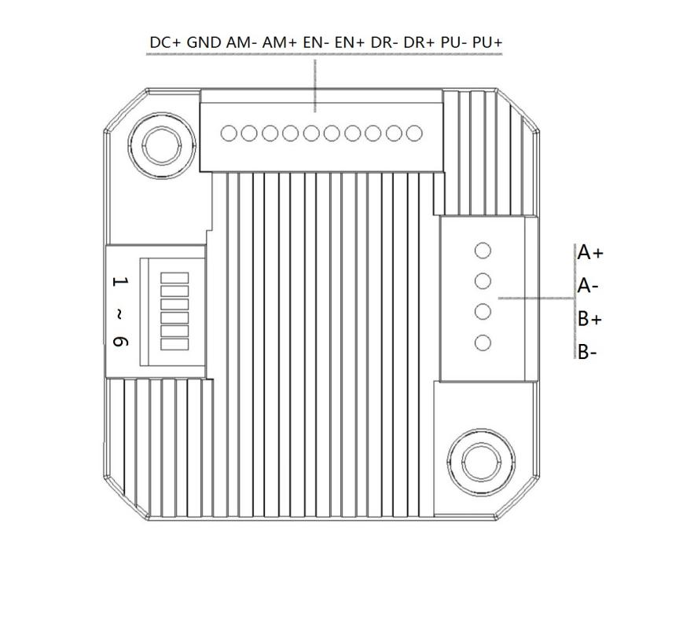

Figure 3.1 IDH42 interface diagram

## **3.2 Interface Description**

The power interface and signal control interface of IDH42 integrated pulse open-loop stepper driver adopt PH2.0-10P pin socket, and the motor interface adopts 3.5-4P pin socket, which has been correctly wired at the factory. The specific definition of the interface is described in the following sections.

### **3.2.1 Control signal interface**

|  |  |
| --- | --- |
| **name** | **Function** |
| PU+ | Pulse control signal: +5V-+24V can be driven, rising edge is effective, every time the pulse isLowChangehighThe motor takes one microstep. In order to reliably respond to the pulse signal, the pulse width should be greater than 2.5μs. |
| PU- |
| DR+ | Direction control signal: +5V-+24V can be driven, high/low level signal. To ensure reliable commutation of the motor, the direction signal should precede the pulse signal by at least 50μs established. |
| DR- |
| EN+ | Enable control signal: +5V-+24V can be driven, high/low level signal. Used to enable or disable the operation of the motor. When EN+ is connected to +5V and EN- is connected to a low level, the driver will cut off the current of each phase of the motor to put the motor in a free state, and the step pulse will not be responded to at this time. When this function is not needed, the enable signal terminal can be left floating. In addition, the EN terminal can also be used to clear the out-of-tolerance alarm signal. |
| EN- |

### **3.2.2 Output signal interface**

The output signal interface is used as the alarm output function by default. When an overvoltage, undervoltage, phase loss, or position error alarm occurs, the output signal is valid.

|  |  |
| --- | --- |
| **name** | **Function** |
| AM+ | Alarm signal output: When overvoltage, undervoltage, or phase loss alarm occurs, the alarm signal output is valid;  For normally open or normally closed connection, see the description in Section 3.4;  Maximum driving current 50mA. |
| AM- |

### **3.2.3 Motor control output interface**

|  |  |  |  |  |
| --- | --- | --- | --- | --- |
| **name** | | **color** | **illustrate** | **Function** |
| Motor | A+ | red | Motor interface | Two-phase stepper motor wiring port, please pay attention to the line sequence;  If you want the opposite initial rotation direction, just swap A+ and A- or swap B+ and B-;  **The wiring has been correctly done at the factory. If it is not necessary, please do not change the wiring sequence at will.** |
| A- | blue |
| B+ | green |
| B- | black |

### **3.2.4 Power input interface**

|  |  |  |  |
| --- | --- | --- | --- |
| **name** | | **illustrate** | **Function** |
| VDC | DC+ | Power interface | Power Input  DC12V~40V |
| GND |

### **3.2.5 Status Indicator**

The indicator light of IDH42 integrated pulse open-loop stepper driver is a retracted green SMD LED, and its basic definition is shown in the following table.

|  |  |  |
| --- | --- | --- |
| **name** | **Function** | **illustrate** |
| Green LED | Power supply, alarm indicator, parameter saving function indicator, factory reset function indicator, DIP switch status indicator; | The light is always on when the power is on normally, and flashes when alarming, saving parameters, restoring factory settings, or switching the dial status. For the flashing rules, please refer to Chapter 6; |

## **3.3 Input control signal**

### **3.3.1 Input control signal interface circuit**

The IDH42 driver control signal end adopts a differential interface circuit, which is applicable to differential signals, single-ended common cathode and common anode interfaces. It has a built-in high-speed optocoupler and has strong anti-interference ability in harsh environments. The interface circuit diagram is shown in Figure 3.2.

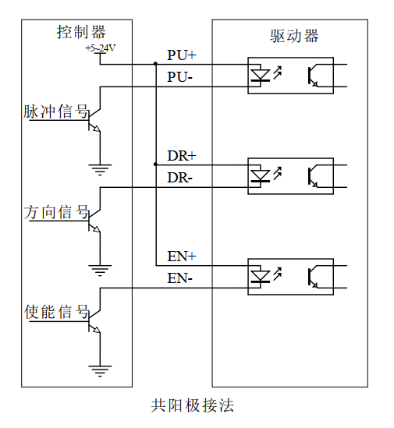 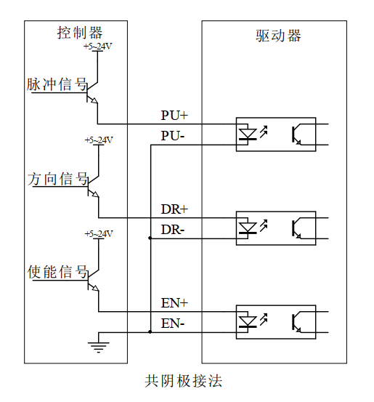

Figure 3.2 Input interface circuit

▶Note: IDH42 is a 5V-24V universal driver, so the signal control end does not need a series resistor!

### **3.3.2 Control signal timing diagram**

In order to avoid some malfunctions and deviations, PU, ​​DR and EN should meet certain requirements, as shown in the following figure:

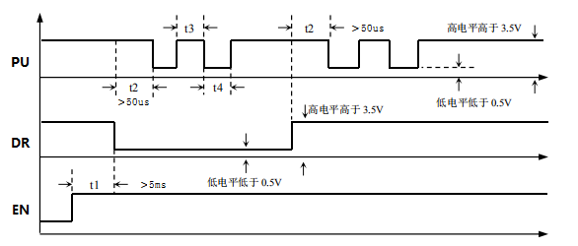

Figure 3.3 Control signal timing diagram

**Notes:**

1. t1: EN (enable signal) should be at least 5ms ahead of DR and confirmed to be high. In general, it is recommended that EN+ and EN- be left floating.
2. t2: DR is at least 5 seconds ahead of the falling edge of PU0μs determines its state high or low.
3. t3: The pulse width is at least 2.5μs.
4. t4: Low level width is not less than 2.5μs.

### **3.3.3 Control signal mode setting**

Pulse trigger edge selection: This function requires program changes.

## **3.4 Output control signal**

After the driver is powered on normally, the effective state of the output interface is initially defaulted to normally open output..

### **3.4.1 Used as alarm output**

The following figure is a wiring diagram when the output signal port is used as an alarm output function:

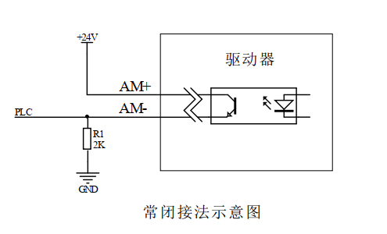

Figure 3.4 Schematic diagram of normally closed connection of output interface

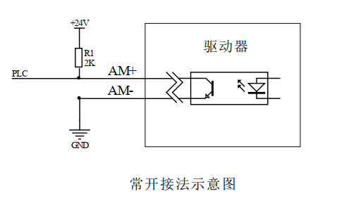

Figure 3.5 Schematic diagram of normally open connection of output interface

## **3.5 Wiring requirements**

1. In order to prevent the driver from being interfered, it is recommended that the control signal use shielded cable, and the shield layer is short-circuited with the ground wire. Except for special requirements, the shield line of the control signal cable is grounded at one end: the host computer end of the shield line is grounded, and the driver end of the shield line is suspended. Only the same point is allowed to be grounded in the same machine. If it is not a real ground wire, there may be serious interference. In this case, the shield layer is not connected.
2. The pulse and direction signal lines are not allowed to be wrapped side by side with the motor lines. It is best to separate them by at least 10 cm. Otherwise, the motor noise will easily interfere with the pulse direction signals and cause inaccurate motor positioning, system instability and other faults.
3. If one power supply supplies multiple drives, they should be connected in parallel at the power supply. Chain connection from one drive to another is not allowed.
4. It is strictly forbidden to plug or unplug the high-voltage terminals of the driver while it is powered on. When the motor is stopped, there is still a large current flowing through the coil. Plugging or unplugging the terminals while it is powered on will cause a huge instantaneous induced electromotive force that will burn out the driver.
5. It is strictly forbidden to connect the wire end to the terminal after tinning it, otherwise the contact resistance may increase and the terminal may be damaged by overheating.
6. The wiring ends must not be exposed outside the terminals to prevent accidental short circuits and damage to the driver.

# **DIP switch function setting**

The IDH42 driver uses a 6-bit dip switch, SW1 is used for current setting, SW2 is used for mode setting, and SW3-SW6 are used for subdivision setting, spontaneous pulse speed settingThe detailed description is as follows:

|  |  |  |  |  |  |
| --- | --- | --- | --- | --- | --- |
| **SW1** | **SW2** | **SW3** | **SW4** | **SW5** | **SW6** |
| **Current setting** | **Mode Settings** | **Segment settings** | | | |

## **4.1 Current Setting**

SW1 sets the output current of the driver. The DIP switches correspond to the default current settings, as shown in the following table.

|  |  |  |
| --- | --- | --- |
| **SW1** | **Open Loop** | |
| Peak(A) | RMS(A) |
| off | 1.4 | 1.0 |
| on | 2.1 | 1.5 |

## **4.2 Mode Settings**

SW2Set the drive's operating mode as shown in the following table.

|  |  |  |
| --- | --- | --- |
| **SW2** | **Working Mode** | |
| off | PU+DR |
| on | Spontaneous pulses |

**▶Note: After the mode setting dial code is modified, it needs to be powered on again for it to take effect.**

## **4.3 Subdivision and spontaneous pulse speed setting**

SW3-SW6 sets the speed setting of the driver in subdivision or spontaneous pulse mode, with a total of 16 levels available.

### **4.3.1 Segmentation Settings**

The DIP switches correspond to the default subdivision settings, as shown in the following table

|  |  |  |  |  |
| --- | --- | --- | --- | --- |
| **Steps/turn** | **SW3** | **SW4** | **SW5** | **SW6** |
| 200 | on | on | on | on |
| 400 | off | on | on | on |
| 800 | on | off | on | on |
| 1600 | off | off | on | on |
| 3200 | on | on | off | on |
| 6400 | off | on | off | on |
| 12800 | on | off | off | on |
| 25600 | off | off | off | on |
| 1000 | on | on | on | off |
| 2000 | off | on | on | off |
| 4000 | on | off | on | off |
| 5000 | off | off | on | off |
| 10000 | on | on | off | off |
| 20000 | off | on | off | off |
| 3600 | on | off | off | off |
| 7200 | off | off | off | off |

### **4.3.2 Spontaneous pulse speed setting**

The DIP switches correspond to the default spontaneous pulse speed settings, as shown in the following table

|  |  |  |  |  |
| --- | --- | --- | --- | --- |
| **RPM** | **SW3** | **SW4** | **SW5** | **SW6** |
| 720 | on | on | on | on |
| 660 | off | on | on | on |
| 600 | on | off | on | on |
| 540 | off | off | on | on |
| 480 | on | on | off | on |
| 420 | off | on | off | on |
| 360 | on | off | off | on |
| 300 | off | off | off | on |
| 240 | on | on | on | off |
| 210 | off | on | on | off |
| 180 | on | off | on | off |
| 150 | off | off | on | off |
| 120 | on | on | off | off |
| 90 | off | on | off | off |
| 60 | on | off | off | off |
| 30 | off | off | off | off |

# **Power supply selection**

The power supply voltage can work normally within the specified range. The IDH42 driver is best powered by a regulated DC switching power supply. It should be noted that the output current range of the switching power supply must be set to the maximum. An unregulated DC power supply can also be used, but it should be noted that the peak value of the rectified voltage ripple should not exceed the specified maximum voltage. It is recommended that users use a DC voltage lower than the maximum voltage to avoid grid fluctuations exceeding the driver voltage operating range.

▶Note:

1. When wiring, pay attention to the positive and negative poles of the power supply and do not connect them in reverse;
2. When wiring, pay attention to the position of the power interface and do not connect it to the motor port. After connecting, it is best to confirm whether it is connected correctly;
3. It is best to use a regulated DC switching power supply;
4. When using an unregulated DC power supply, the power supply current output capacity should be greater than 60% of the driver set current;
5. When using a regulated DC switching power supply, the output current of the power supply should be greater than or equal to the operating current of the driver;
6. To reduce costs, two or three drivers can share one power supply, but the power supply must be large enough.

# **Indicator lights and alarm indicators**

IDH42 integratedPulse open loopStepper DriverThere is a green LED and a red LED. One can be used as a power indicator, and the other can be used as a fault indicator, a DIP switch indicator, or a parameter save or restore indicator. The specific relationship is shown in Table 6.1 below:

When the driver is powered on, the green LED is always on, and when the driver is powered off, the green LED is off.

When the DIP switch is turned, the green LED will flash twice quickly. This is normal and indicates that the DIP state switch is valid.

When the drive fails, the red and green lights flash alternately, and different flashing patterns indicate different fault information. When the fault is eliminated by the user, the green LED remains on and the red LED goes out.

When saving/restoring parameters, the red and green lights flash alternately in a cycle. When saving/restoring parameters is completed, the green LED is always on and the red LED is off.

Table 6.1 LED status indication

|  |  |  |  |
| --- | --- | --- | --- |
| **Number of LED flashes** | | **Phenomenon** | **illustrate** |
| Green LED | Red LED | After the green light flashes, the red light flashes |  |
| 0 | - | Green light is always on, red light is off | Driver Enable |
| 1 | - | Green light flashes, red light off | Receive pulse signal |
| 1 | 1 |  | Normal out-of-tolerance alarm |
| 2 | 1 |  | Pulse received in disabled state |
| 3 | 1 |  | (Overvoltage)Out of tolerance alarm |
| 4 | 1 |  | (Undervoltage)Out of tolerance alarm |
| 1 | 4 |  | Overpressure alarm |
| 2 | 4 |  | Undervoltage alarm |
| 1 | 5 |  | Overcurrent alarm(reserve) |
| 1 | 6 |  | AB phase loss alarm |
| 2 | 6 |  | Only A phase missing alarm |
| 3 | 6 |  | Only phase B is missing. |
| 1 | 8 |  | Timeout alarm in homing mode(reserve) |
| 1 | 2 |  | Restoring parameters |
| 2 | 2 |  | Saving parameters in progress |

# **Warranty and after-sales**

## **7.1 Warranty**

**7.1.1 Free warranty**

Our company solemnly promises that if any of our products are damaged during use due to the product itself, we will provideOne yearFree repair service. The shipping cost of the product shall be borne by both parties.

**7.1.2 Warranty exclusion**

1. The driver is damaged due to the customer's own wiring error;
2. The drive is damaged due to exceeding the rated working voltage;
3. The DC power supply driver is connected to the AC power supply, causing the driver to be damaged;
4. The driver is damaged due to the customer's extremely harsh on-site environment, such as humidity, extreme cold, extreme heat, etc., without informing our company in advance;
5. The customer dismantles the drive housing without permission or the serial label number is torn off;
6. 15 days after the customer confirms receipt, the housing is obviously damaged or hit, resulting in damage to the drive;
7. Forceful natural disasters, such as fire, earthquake, tsunami, typhoon, etc.;

In the above cases, our company will charge a certain amount of repair cost after evaluating the interests of all parties. In other cases, repairs will be provided free of charge forever.

## **7.2 Exchange**

**7.2.1 Replacement of defective product**

For faults in new products, our company provides three months of free replacement service.

After our technical support staff confirms that the problem is with the product itself, they will send the product back to our company to avoid wasting time and postage on the round trip. Customers need to send the faulty product back by express or logistics first, and our company will send another new product back to the customer as soon as possible after receiving it.

**Notice:**All our products undergo rigorous testing and aging before leaving the warehouse, so it is extremely rare for new products to malfunction. Please be sure to read the instructions carefully or consult our technical support staff when operating, or our technical support staff will remotely assist customers in operating.

* **Please note the following points when exchanging goods:**

1. Please ensure that the packaging is complete when sending back to avoid damage during transportation;
2. Please ensure that the attached accessories are complete when exchanging;
3. Each driver should be packed in its original box to avoid secondary damage to the product during transportation;
4. If after the driver is sent back, it is confirmed that the failure is not due to product failure, but due to the customer's negligence in operation, which leads to mistakenly thinking that the driver is faulty, the company will not bear the shipping fee (the customer's negligence in operation includes: damage to the driver due to wrong wiring, poor wiring leading to mistakenly thinking that the driver is damaged, operation errors causing the driver to fail to work properly, etc.).

**7.2.2 Exchange for non-product failure**

If the customer is not satisfied with the appearance or function of the product received and wants to replace it with a better driver, he or she can apply for a replacement service from our company within one week of receiving the product. After verification, our company will return the product. If the returned product is confirmed to be undamaged, with complete accessories and good packaging, the company will replace it with another product for the customer. For the replaced product, if there is a price difference, the customer will make up the difference.

**Note: The replaced product will no longer be eligible for the non-product fault replacement service. The round-trip shipping costs and other costs incurred by the non-product fault replacement service shall be borne by the customer!**

## **7.3 Returns**

Our company provides a 7-day return service for products with quality problems. If you find quality problems with the product within 7 days of receiving the product (based on the actual date of receipt by the customer), please communicate with our salesperson or technical support personnel in time. After our technical support personnel confirms that it is a quality problem of the company's product itself, the customer can send the original complete product and its inner and outer packaging, accessories and shipping order back to our company by express or logistics.

If the customer still insists on returning the goods after our company has checked and confirmed that they are correct, the round-trip shipping costs and all other costs incurred shall be borne by the customer.

* **Please note the following points when returning goods:**

(1) Please contact the relevant department of our company before making a refund;

(2) The product must be in new condition and intact packaging. Please send it back to our company by express or logistics;

(3) We will not accept any complaints caused by customers, such as product appearance damage, incomplete accessories, etc.

## **7.4 After-sales service**

If you need after-sales service support when using this product, please contact our company as soon as possible.

National free service hotline: 0755-23206995;

Technical specialist service hotline: 18576758897 (Mr. Xie), 17666115681 (Mr. Tuo);

Service hours: 8:30-17:30, Monday to Friday (except national holidays).

# **Revision History**

|  |  |  |  |
| --- | --- | --- | --- |
| Version Number | illustrate | Modify deadline | Preparer/Reviewer |
| V1.0.0 | Initial use version; | 2022.06.01 | TCJ, JQ/XH |
| V1.0.1 | Optimize some details;  Add company logo; | 2022.7.19 | TCJ/XH |
| V1.0.2 | Change indicator lights and alarm indications; | 2024.6.6 | TCJ/XH |